Book

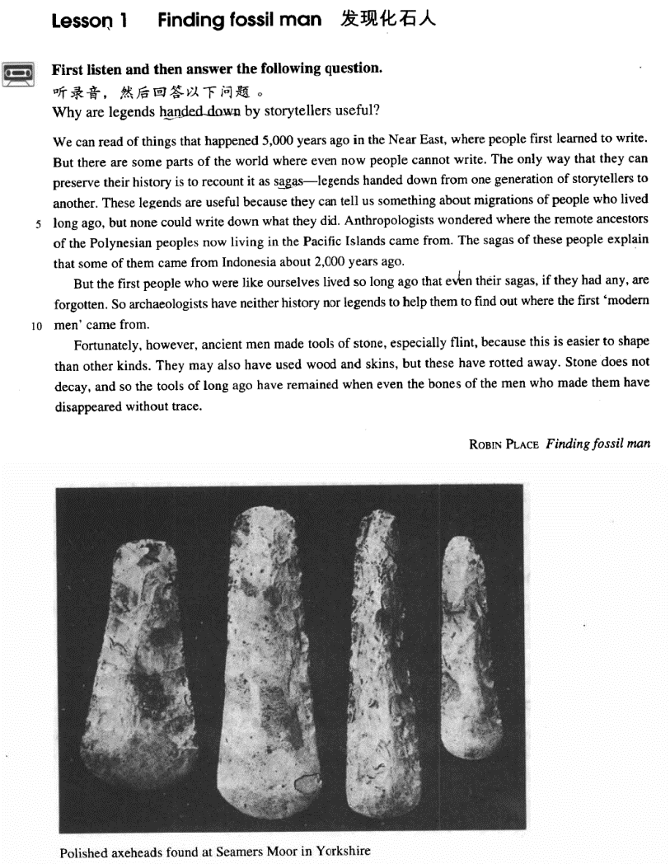

课文

We can read of things that happened 5,000 years ago in the Near East, where people first learned to write.

我们从书籍中可读到5,000 年前近东发生的事情，那里的人最早学会了写字。

But there are some parts of the world where even now people cannot write.

但直到现在,世界上有些地方，人们还不会书写。

The only way that they can preserve their history is to recount it as sagas -- legends handed down from one generation of storytellers to another.

他们保存历史的唯一办法是将历史当作传说讲述，由讲述人一代接一代地将史实描述为传奇故事口传下来。

These legends are useful because they can tell us something about migrations of people who lived long ago,

这些传说是有用的，因为他们告诉我们很久以前生活在这里的移民的一些事情。

but none could write down what they did.

但是没有人能写下来。

Anthropologists wondered where the remote ancestors of the Polynesian peoples now living in the Pacific Islands came from.

人类学家过去不清楚如今生活在太平洋诸岛上的波利尼西亚人的祖先来自何方，

The sagas of these people explain that some of them came from Indonesia about 2,000 years ago.

当地人的传说却告诉人们：其中一部分是约在2,000年前从印度尼西亚迁来的。

But the first people who were like ourselves lived so long ago that even their sagas, if they had any, are forgotten.

但是，和我们相似的原始人生活的年代太久远了，因此，有关他们的传说既使有如今也失传了。

So archaeologists have neither history nor legends to help them to find out where the first "modern men" came from.

于是，考古学家们既缺乏历史记载，又无口头传说来帮助他们弄清最早的“现代人”是从哪里来的。

Fortunately, however, ancient men made tools of stone, especially flint, because this is easier to shape than other kinds.

然而，幸运的是，远古人用石头制作了工具，特别是用燧石，因为燧石较之其他石头更容易成形。

They may also have used wood and skins, but these have rotted away.

他们也可能用过木头和兽皮，但这类东西早已腐烂殆尽。

Stone does not decay, and so the tools of long ago have remained when even the bones of the men who made them have disappeared without trace.

石头是不会腐烂的。因此，尽管制造这些工具的人的骨头早已荡然无存，但远古时代的石头工具却保存了下来。

词汇讲解

— Winston Churchill What am I supposed to do?

Lesson1 Finding fossil man

recount [rɪ'kaʊnt]

v. 叙述，讲述

recount / relate / report sth. to sb. tell sb. (about) sth.

She recounted the events of the previous week to the police.

We know instinctively, just as beekeepers with their bees, that misfortune might overtake us if the important events of our lives were not related to it.

History does not relate whether his friend accepted his medical help, but in all probability he did.

After telling several of his friends about the theft, Dimitri found out that his neighbour, Aleko, had suddenly acquired a new lamb.

After the theft to several of his friends, …

(A) telling (B) reporting

(C) expressing (D) counting narrate

narrative

account account for …

Afro-Americans account for 12% of the US population.

The gene they discovered doesn’t account for all those cases. discount

Members get a 20% discount. saga ['sɑ:gə]

n. 长篇英雄传说

saga: a prose narrative recorded in Iceland in the Middle Ages. It’s written about the Vikings of Norway and Iceland.

epic epic legend

the legend of Robin Hood Robin Hood is a legendary hero. myth / mythology

Greek myths / mythology

He had lived in it as a child when it was already disappearing, and his hero was firmly rooted in his memories and experiences, and in both the history and the mythology of the vanished frontier.

migration [maɪ'greɪʃn]

n. 迁移，移居

migrate migration migrant immigrate immigration

immigrant

illegal / permanent immigrants

emigrate *from* immigrate *to*

Europeans emigrating *from* their homelands after World War Ⅱ were encouraged to immigrate *to* Australia.

emigration emigrant

|  |  |  |
| --- | --- | --- |
| migrate | migration | migrant |
| immigrate | Immigration | immigrant |
| emigrate | emigration | Emigrant |

anthropologist [7ænθrə'pɒlədʒɪst]

n. 人类学家

anthropologist anthropology “*anthrop* ” = man

anthropoid

Gorillas, chimpanzees and gibbons are all anthropoid apes. anthropogenic

The pending extinction of some species are caused by anthropogenic factors, directly or indirectly.

To preserve wilderness areas in their natural state can lessen anthropogenic disturbance to Nature, which is of great importance to the environmental conservation and ecological equilibrium.

I strongly agree with the assertion that significant advances in knowledge require expertise from various fields. The world around us presents a seamless web of physical and anthropogenic forces, which interact in ways that can be understood only in the context of a variety of disciplines. Two examples that aptly illustrate this point involve the fields of cultural anthropology and astronomy.

philanthropist

“*phil* ” = love philosopher

“*(o)logy* ” = to study biology

geology psychology

physiology

archaeologist archaeology archaic

ancestor ['ænsestə(r)]

n. 祖先

ancestor

*an* (=ante) + *ces* (to go) + *tor* (person)

Yandi and Huangdi are the legendary ancestors of the Chinese nation. forefather

forebear descendant

He is a direct descendant of Confucius. offspring

the conflict between parents and their offspring posterity

These works of art are preserved for posterity. rot [rɒt]

v. 腐烂

Too much candy will rot your teeth / make your teeth rot. rot away

rotten

One rotten apple spoils the whole barrel. decay

Too much candy will decay your teeth / make your teeth decay. Each civilization is born, it culminates, and it decays.

find: discover

fossil man: ancient man; prehistoric man encourage → spur

prohibit / forbid → ban compete → vie nominate → name alliteration 头韵

Finding fossil man

Spare that spider Matterhorn man The sporting spirit Pride and Prejudice Prince and Pauper

World Wide Watch

A Delicious Dish A Day

We can read of things that happened 5,000 years ago *in the Near East, where people first learned to write*.

read of

speak of / talk of

hear of / learn of / know of

think of dream of Of Truth Of Death Of Love Of Envy

Of Human Bondage

I saw him at the party *yesterday*.

We can read of things that happened 5,000 years ago in the Near East,

*where people first learn to write*.

Several cases *have been reported in Russia recently* of people who can

read and detect colors with their fingers, and even see through solid doors

and walls.

He maybe conceited, ill-mannered, presumptuous or fatuous, but I do not

turn *for protection* to dreary clichés about respect of elders — as if mere age were a reason for respect.

If we glimpse the unutterable, it is unwise to try to utter it, nor should we seek to invest *with significance* that which we cannot grasp.

What is an intellectual? I shall define him as an individual who has

elected as his primary duty and pleasure in life the activity of thinking in

Socratic way about moral problems.

What is an intellectual? I shall define him as an individual who has elected *as his primary duty and pleasure in life* the activity of thinking in

Socratic way about moral problems.

As a logical consequence of this development, separate journals have now appeared aimed mainly towards either professional or amateur readership.

As a logical consequence of this development, separate journals *have now*

*appeared* aimed mainly towards either professional or amateur readership.

the Near East the Middle East the Far East

We can read of things that happened 5,000 years ago in the Near East,

*because* people first learned to write *there*.

We can read of things that happened 5,000 years ago in the Near East, where people first learned to write.

We endeavour to avoid the old, romantic idea of a gusher, *which* wastes oil and gas.

We endeavour to avoid the old, romantic idea of a gusher, *because it*

wastes oil and gas.

The small ship, Elkor, *which* had been searching the Barents Sea for weeks, was on its way home.

The small ship, Elkor, *after she* had been searching the Barents Sea for weeks, was on its way home.

Much to the aristocrat's amusement, the gaoler returned a few moments later with a pair of glasses and the usual copy of the letter *which* he proceeded to read to the prisoner.

Much to the aristocrat's amusement, the gaoler returned a few moments later with a pair of glasses and the usual copy of the letter *and* he proceeded to read *it* to the prisoner.

I have to be very careful not to offend the boss, who could fire me at any time.

I have to be very careful not to offend the boss, *because he* could fire me at any time.

The action, which has aroused universal disapproval, is nevertheless the

only solution.

The action, *although it* has aroused universal disapproval, is nevertheless the only solution.

造句：最近几年大批农民工 (migrant workers from the countryside) 涌

入大城市，因为他们在那里可以找到不错的工作并且养活家人。 The past few years witnessed the great influx of migrant workers from the countryside to big cities, where they could secure decent jobs and support

their families.

There seem / appear to be … There used to be …

There happen to be … There is / are going to be …

造句：有越来越多的人对英语有兴趣。

There are more and more people who are interested in English.

无灵主语 / 物称主语

(inanimate subject) 满堂花醉三千客一剑光寒十四州

唐 贯休和尚 献钱尚父

颠狂柳絮随风舞轻薄桃花逐水流

唐 杜甫 绝句漫兴(其五)

一条雪浪吼巫峡千里火云烧益州

唐 李商隐 送崔珏往西川

造句：有越来越多的人对英语有兴趣。

There are more and more people who are interested in English. There is growing interest in English.

造句：人们普遍同意妇女应该享有和男人完全的平等。

People generally agree that women should enjoy full equality with men. There is general agreement that women should enjoy full equality with men.

Except for one or two places such as Zermatt and Chamonix, which had rapidly become popular, Alpine villages tended to be impoverished settlements cut off from civilization.

be cut off from …

be out of touch with … be isolated from …

be separated from …

These regions are cut off from

out of touch with isolated from separated from

造句：但是现在在中国依然有部分地区人们还吃不饱肚子(cannot

satisfy one’s hunger)。

But there are some parts of China where even now people cannot satisfy their hunger.

The only way *that they can preserve their history* is to recount it as sagas—legends *handed down from one generation of storytellers to*

*another*. preserve

preserve historical records preserve food / one’s eyesight

conserve

conserve natural resources conserve wildlife

reserve

reserve one’s energy all rights reserved

I reserve the right to disagree. reserve a table for 2

The old building is in a good state of except for the wooden floors.

*(CET6)*

(A)observation (B)preservation

(C)conservation (D)reservation

动词不定式做表语时, 若前面出现了实义动词“do”, 则常去掉“to” All I have to do is dream.

The best thing you can do now is write her an apology.

The only thing to do was ask them to come half an hour later than the other guests. Then they arrived just when we wanted them.

All I wanted was *to* help him.

hand sth. down: pass sth. from older people to younger ones The recipe was handed down *from* an ancestor of the family. story-teller tell stories

fortune-teller tell one’s fortune

These legends are useful because they can tell us something about migrations of people who lived long ago, but none could write down *what they did*.

Anthropologists wondered where the remote ancestors of the Polynesian peoples now living in the Pacific Islands came from.

a distant relative

a close / near relative

… who live in the Pacific Islands now …

But the first people *who were like ourselves* lived so long ago that even their sagas, *if they had any*, are forgotten.

the first people who were like ourselves fossil man

people who lived long ago the first ‘modern men’ ancient men

… the first people like ourselves … be similar to …

… the first people who were similar to ourselves …

… the first people similar to ourselves … resemble

... the first people who resembled ourselves …

... the first people resembling ourselves … bear a resemblance to ...

... the first people who bore a resemblance to ourselves ...

... the first people bearing a resemblance to ourselves ...

Your school may have *done away with* winners and losers, but life has not.

In some schools they have *abolished* failing grades; they'll give you as many times as you want to get the right answer. This doesn't bear the slightest resemblance to anything in real life.

God’s reasons, if He has any, are opaque to us.

There is every likelihood that the costs of the monitoring system, such as the purchase, maintenance and updates of software, employment of extra personnel in charge of it, will offset or even outweigh additional revenue, if there is any.

His descendants, if any, never left the island. He is seldom, if ever, absent from work.

He shaped the clay into a vase.

Like it or not, our experiences shape our personalities. He thundered at the door.

The street was veiled in darkness.

A gust of wind whipped the dust along the road. Honey, I forgot to duck.

域民不以封疆之界

may / might have done must have done

can not / could not have done should / ought to have done

should not / ought not to have done

She looks very happy. She have passed the exam.

I guess so. It’s not difficult at all.

(A) should (B) could

(C) must (D) might

I can’t find my purse anywhere.

You have lost it while shopping.

(A) may (B) can

(C) should (D) would

I’m sorry. I at you the other day.

Forget it. I was a bit out of control myself.

shouldn’t shout

shouldn’t have shouted

mustn’t shout

mustn’t have shouted

The policeman declared that the blow on the victim’s head from behind.

should have been made

must have been made

would have been made

ought to have been made skin

hide fur feather

fur and feather fin, fur and feather metonymy 借代

A bald slipped out of the house.

He has been messing around with several skirts of his class. The crown should not yield to the cross.

巾帼不让须眉

过尽千帆皆不是斜晖脉脉水悠悠

Stone does not decay, and so the tools of long ago have remained when even the bones of the men *who made them* have disappeared without trace.

He walks when he might take a taxi. Why do you walk when you have a car? disappear / vanish without trace

The burglar slipped out of the house and then disappeared / vanished

without trace.

Problem-Solution Pattern